# DOKUMENTACIJA SAJTA

Student:Dijana Lazic 19/18

Sadrzaj

**Uvod1**

Korisceni programski jezici2

Opis funkcionalnosti3

Template4

**Organizacija4**

Organizaciona sema5

Mapa sajta6

Slike stranica I opisi funkcionalnosti7

**Kodovi8**

HTML9

CSS10

JAVASCRIPT11

jQuery12

# Uvod

## Korisceni programski jezici:

1. HTML
2. CSS
3. JAVASCRIPT
4. JQUERY + plugins
5. BOOTSTRAP

## Opis funkcionalnosti:

Kreiran sa ciljem da korisnicima pruzi sav sadrzaj na jednoj stranici(index.html),pozadina ovog sajta funkcionise na sledeci nacin:

Dinamicko ucitavanje I ispisivanje(JS-om) prilikom ucitavanja stranice:

* Linkovi drusvenih mreza u meniju
* Blok sa trima slikama( koje nude opis nacina usluga)
* Blok sa sest slika(kategorija usluga)
* Blokovi (tipa Card) u okviru bootstrapovog slajdera
* Blok sa trima slikama, medju kojima je centralni dinamicki ispisan slajder
* Unutar plugina-a simpleLightBox –slike
* Sadrzaj unutar forme(ddl liste)sa drzavama I godinama
* Dodeljuju se dogadjaji tekstualnim poljima I sumbit dugmetu(kojima se kasnije proverava ispravnost forme)

Zahvaljujuci jQuery-ju se:

* Otvara podmeni klikom na strelicu
* Klikom na dugme ili otkriva ili sakriva sadrzaj nekog teksta
* Skrolovanjem menja boja menija I velicina, a dodaje mali pomocnik u uglu(strelica koja vodi do vrha stranice)
* Slajder okrece tri slike unete JS-om(kao sto je I napomenuto ranije, osim cinjenice da se odnosi na onaj pod naslovom ‘Top categories’,preostalim dvoma upravljao je Bootstrap)
* Iskakajuca galerija prikazuje(simpleLightBox plugIn)
* Broji kolicina izabranih artikala klikom na +/- I povecava broj unutar polja
* Hover efektom ili na srpskom- prelaskom misa- preko slike se sklanja I dodaje klasa koja cini sadrzaj prozirnim kako bi se prikazao tekst
* Otkriva identitet umetnika sajta ukoliko se klikne na link Author nakon kojeg se pokrece jQuery-jev modal plug-in

## Template

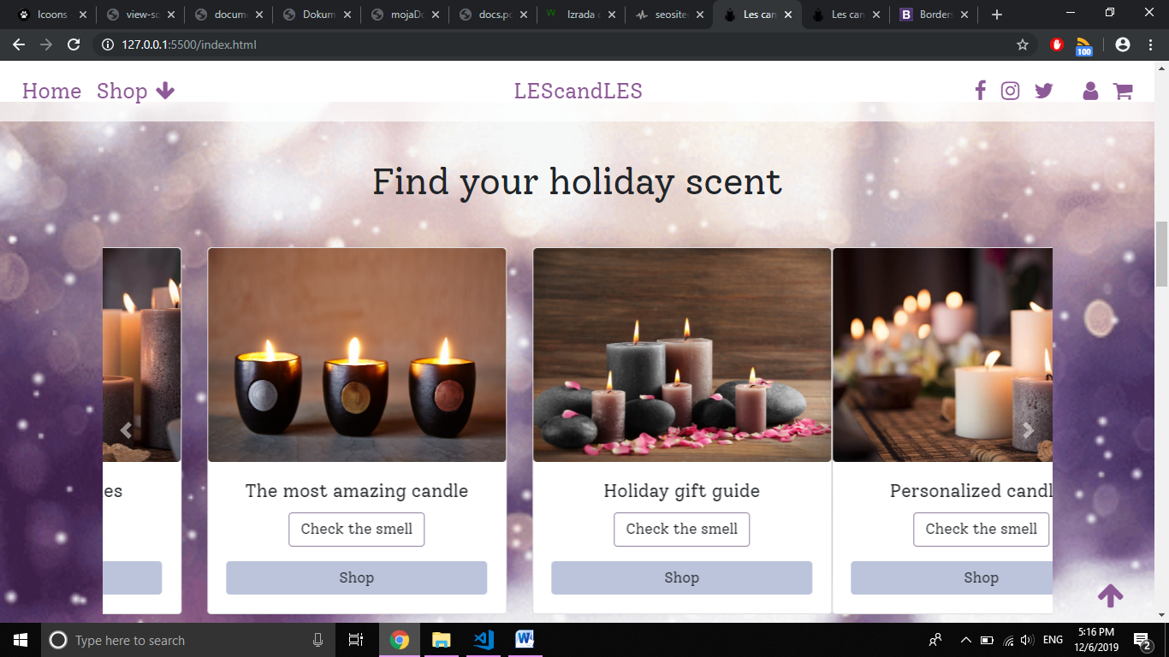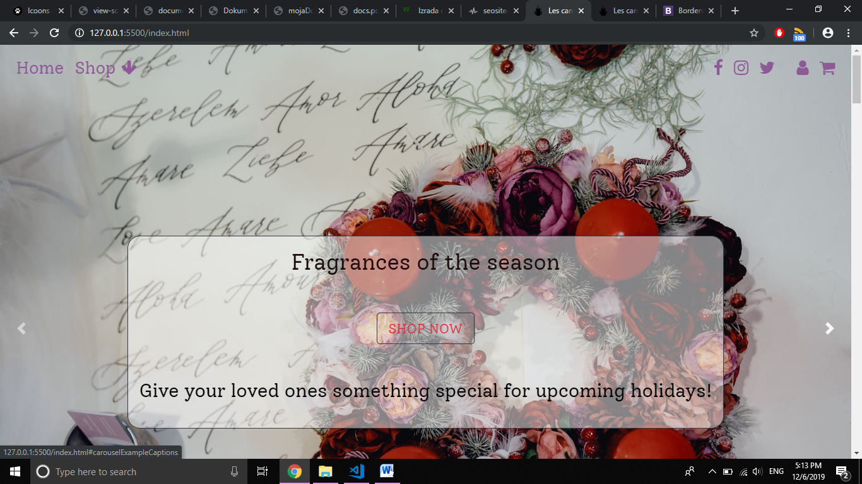 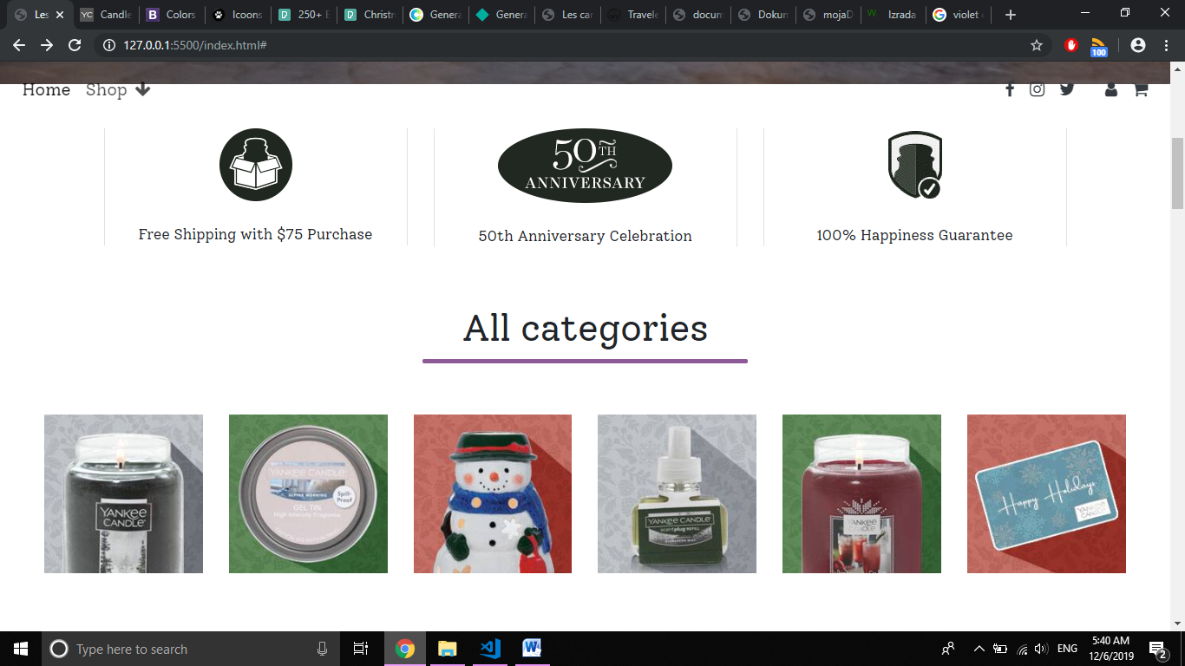

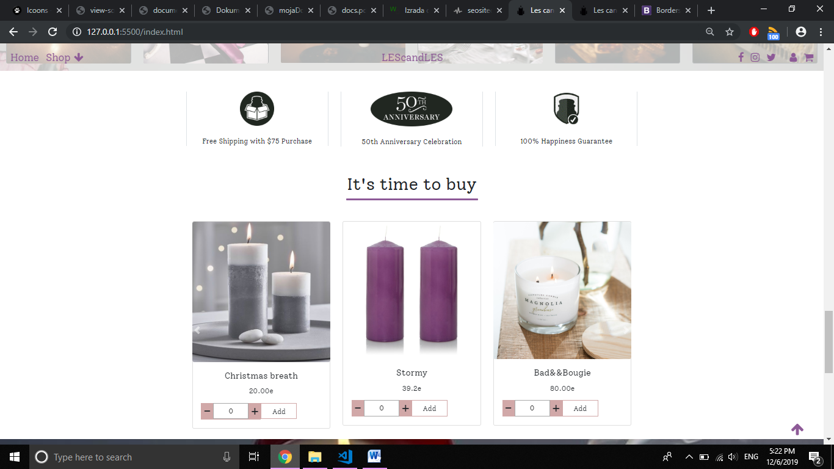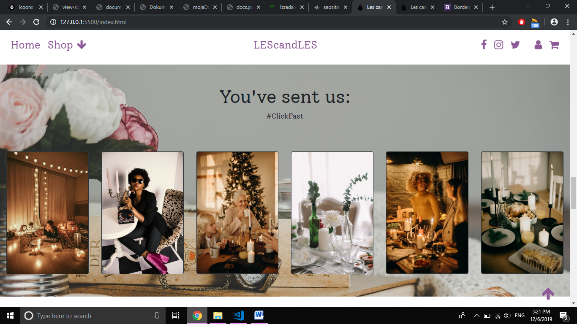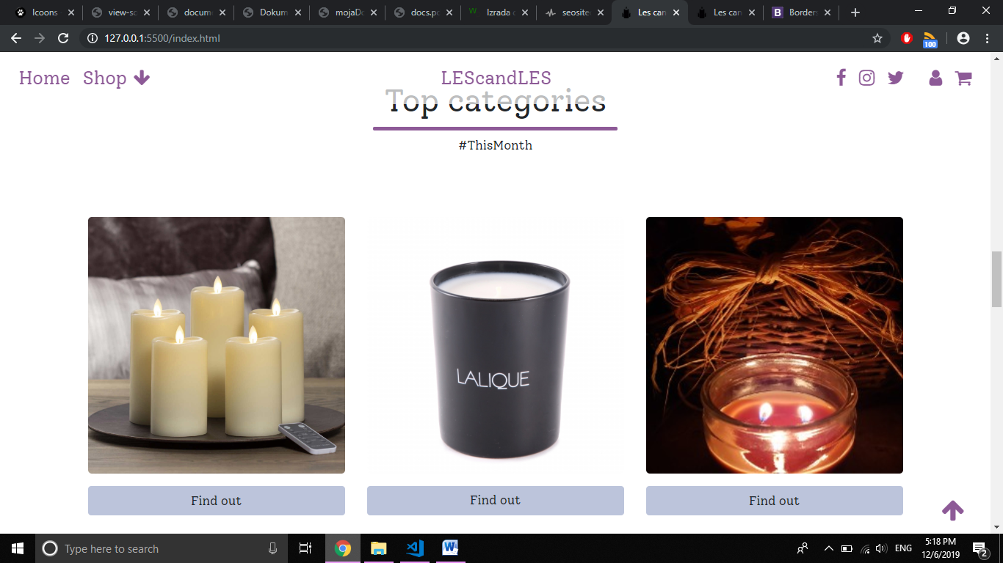

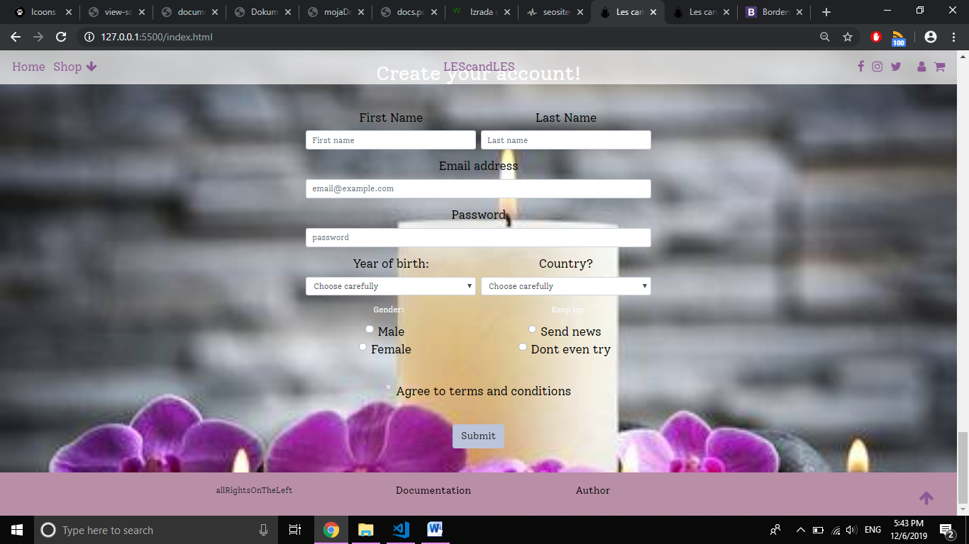

# Organizacija

## Organizaciona sema

S obzirom na to da je single page stranica, njena sema izgleda jednostavno ovako:

INDEX.HTML

## Mapa sajta

## Slika stranica I opisi funkcionalnosti

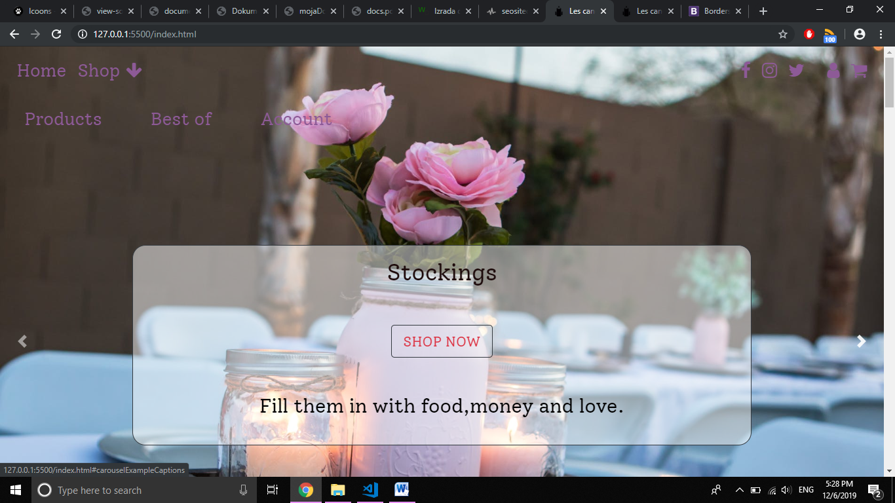

Koristeci boostrap, prva implementacija njihovog koda se realizovala kroz slajder(e) koji se nalazi u pozadini menija ispisanog rucno, a kojem jQuery omogucava ,klikom na strelicu, da otvori podmeni koji vodi do nizeg dela pocetne(a I jedine) stranice.

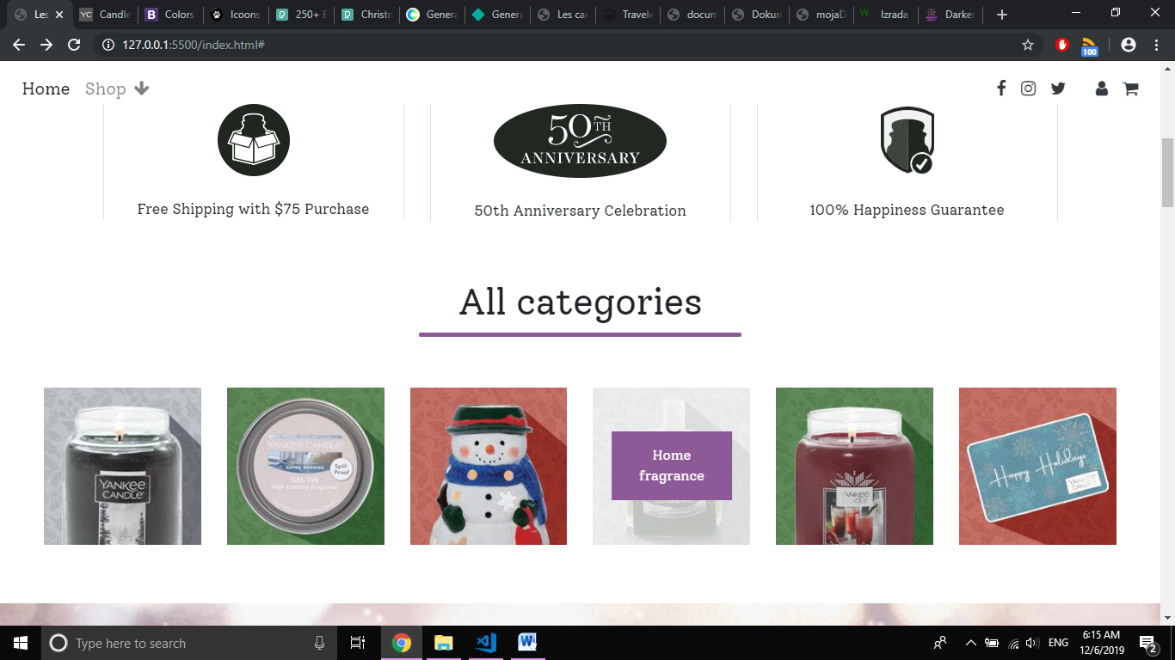

Ova sekcija je dinamicki ispisana kroz JS, a suptilan CSS kod se izvrsava prelaskom misa na slicice kategorija,u kojima se prikazuje tekst koristeci funkciju napisanu jQuery-jem.

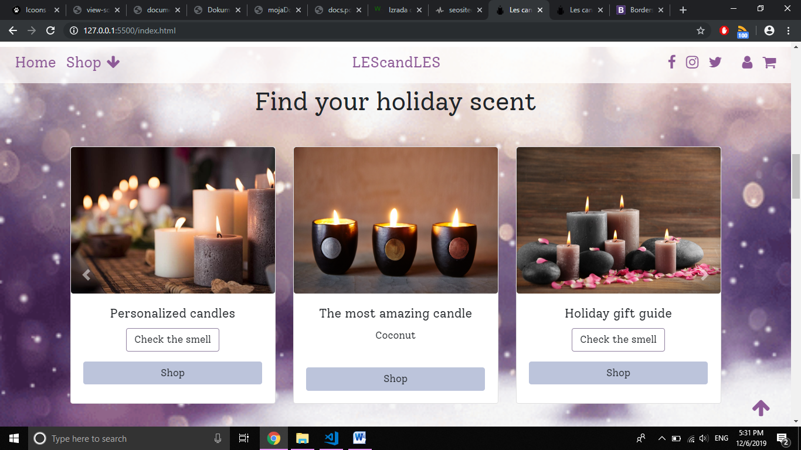

Nakon odredjene duzine(650) skrolovanja misom, prikazuje se drugacija verzija menija(sa pozadinskom prozirnom bojom I nazivom sajta u sredini),a u desnom donjem uglu stranice, viri strelica koja vraca na vrh stranice ako se na nju klikne(jQuery).

Za izgled kartica se I ovog puta pobrinuo Bootstrap,a uz malu pomoc autora I dinamicki ispisali.Takodje, koristeci jQuery funkciju,klikom na link ‘’Check the smell” se *reveal*-uje miris sveca sa slike. U slucaju da se korisnik opredeli za to I klikne Shop, izaci ce mu obavestenje u vidu alert() metode koja ga upozorava da je to jedino moguce uradili ukoliko se pritom ulogovao na stranicu.

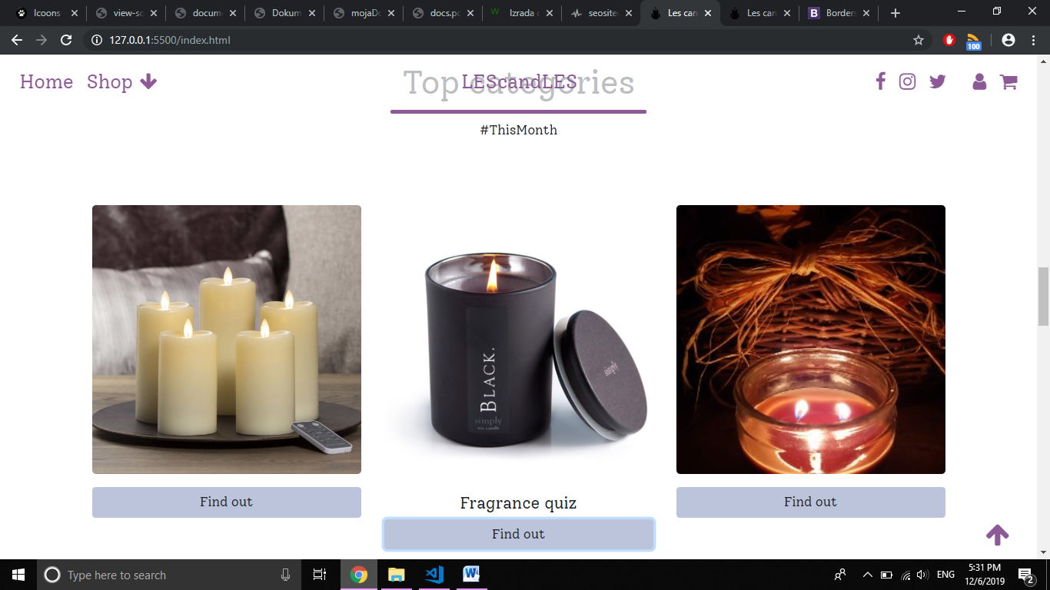

Premda golim printscreenom oku nevidljiva, u sredini ove dinamicki ispisane sekcije, se pokrece niz slika(3) koje stvaraju efekat slajdera(radjene JS-om),a kad bismo kliknuli na dugme Find out, pozvala bi se jQury funkcija koja bi prikazala,pa potom istim pozivom odgovorila sa skrivanjem (this) teksta.

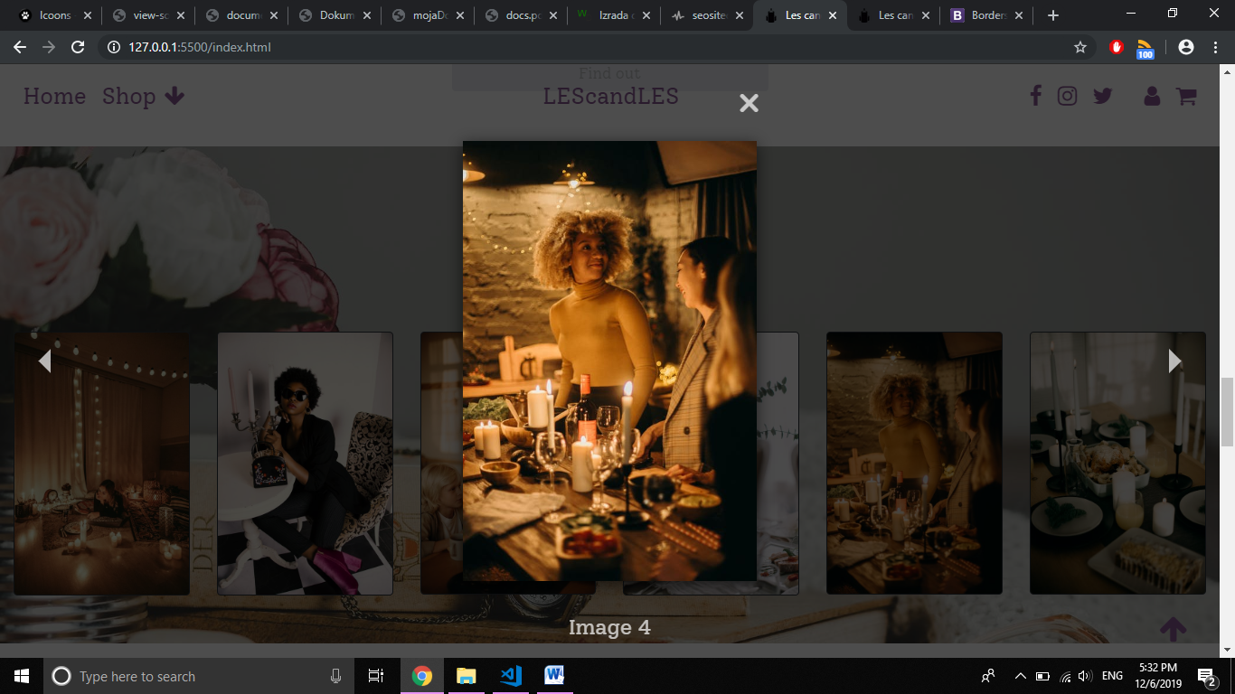

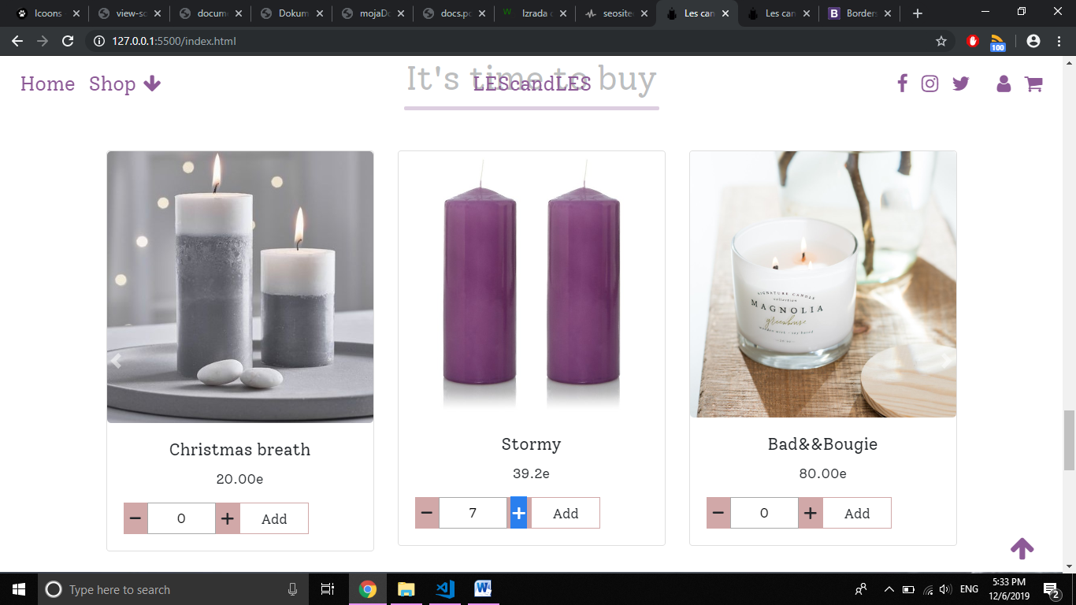Naizgled spaljeni deo stranice, dozvoljava korisnicima da, ukoliko kliknu na ,,mini-galeriju” uzivaju u simpleLightBox jQuery plugin-u koji omogucava iskakanje I veci prikaz slike, iza koje se zaledi(ironija) ostatak stranice sve dok se ne klikne na X u cosku.

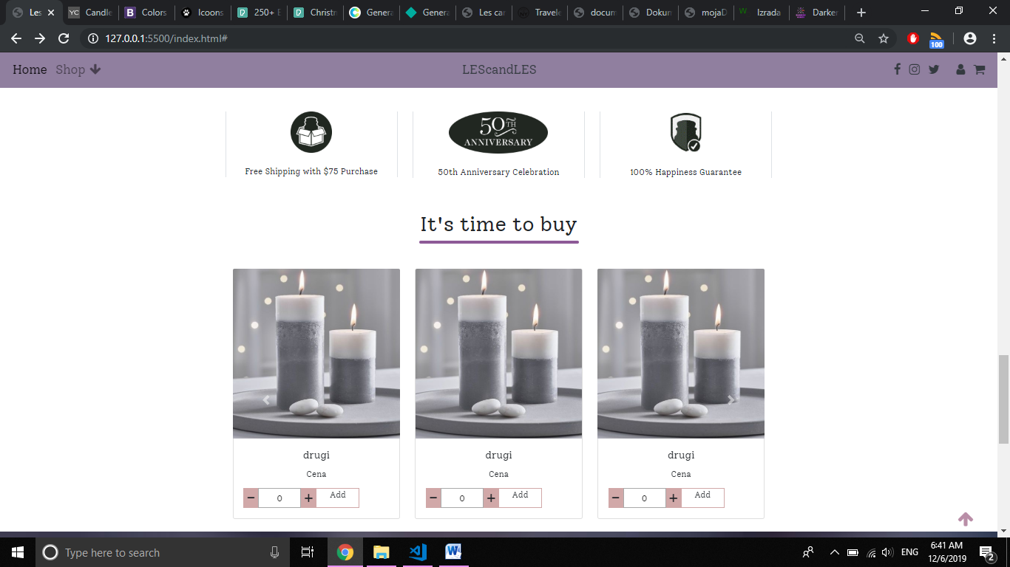

Boostrapov poslednji put(na ovom sajtu) iskoriscen slajder u kojem se pomeraju proizvodi , nudi vise ponuda ukoliko se klikne na strelice sa strane.Odabirom kolicine proizvoda klikom na + ili -, se povecava odnosno smanjuje broj unutar input taga. Ukoliko neko(nadamo se slucajno) smanji broj tj klikne – kad je 0 proizvoda izabrano, radjeno jQueryjem se obavestava korisnik alert() metodom.



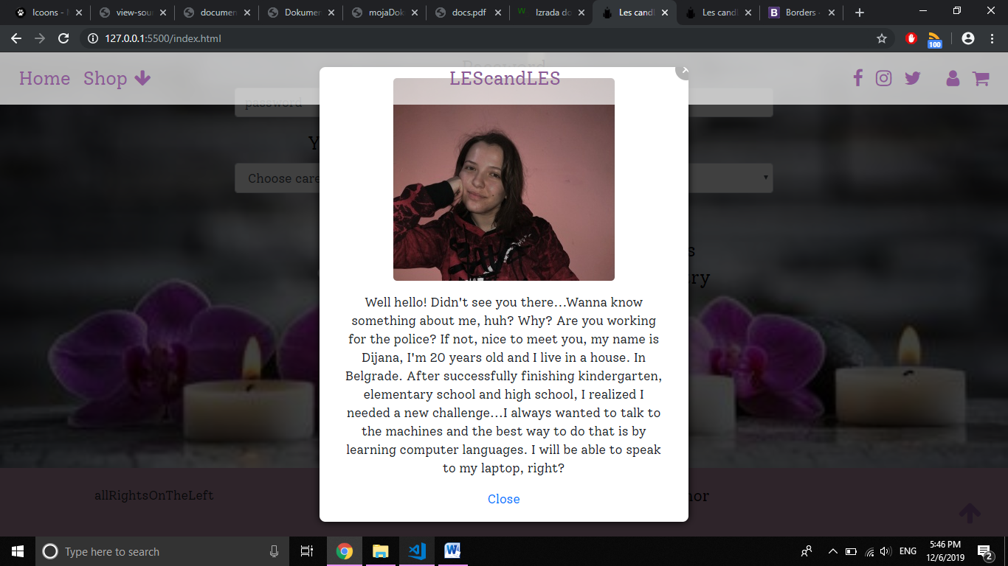U formi se od korisnika trazi da je pre svega ispostuje I popuni sva navedena polja, a ukoliko to ne uradi, upozorava se na sledece nacine: krece se od prva 4 polja nakon kojih kad se izadje iz njih se ispod ili pojavi da nije u dobrom formatu ili da nije uneseno;godina rodjenja kad se izabere se proverava da li je korisnik punoletan(tj stariji od 18),a za sve ostalo vazi da ispisuju ispod gresku ukoliko je ima kad pokusa da se posalje forma.

Za detalje o autoru se klikom na taj link otvara modal(jQuery plugin) u kojem se nalaze dodatne informacije.

# Kodovi

## HTML

<!DOCTYPE html>

<html lang="en">

<head>

<!--metagovi-->

<meta charset="UTF-8">

<meta name="viewport" content="width=device-width, initial-scale=1.0">

<meta http-equiv="X-UA-Compatible" content="ie=edge">

<meta name="keywords" content="candles,categories,scents,holidays"/>

<meta name="author" content="Dijana Lazic" target="_blank"/>

<meta name="description" content="Your favourite smells gathered in candles,making a perfect gift for loved one during holidays "/>

<title>Les candLes</title>

<!--linkovi-->

<link rel="stylesheet" type="text/css" href="bootstrap-4.3.1-dist/css/bootstrap.min.css"/>

<link rel="stylesheet" type="text/css" href="css/style1.css"/>

<link rel="shortcut icon" href="img/icona.ico"/>

<link rel="stylesheet" href="https://cdnjs.cloudflare.com/ajax/libs/jquery-modal/0.9.1/jquery.modal.min.css" />

<link href="https://fonts.googleapis.com/css?family=Solway&display=swap" rel="stylesheet">

<link rel="stylesheet" type="text/css" href="js/simpleLightbox-master/dist/simpleLightbox.min.css"/>

<link rel="stylesheet" href="https://cdnjs.cloudflare.com/ajax/libs/font-awesome/4.7.0/css/font-awesome.min.css">

</head>

<body>

<!--menislajder-->

<div class="container-fluid">

<div class="row fixed-top" id="meni">

<div class="col-lg-12">

<nav class="navbar navbar-expand-md navbar-light ">

<button class="navbar-toggler" type="button" data-toggle="collapse" data-target="#navbarTogglerDemo02" aria-controls="navbarTogglerDemo02" aria-expanded="false" aria-label="Toggle navigation">

<span class="navbar-toggler-icon"></span>

</button>

<div class="collapse navbar-collapse" id="navbarTogglerDemo02">

<ul class="navbar-nav mt-2 mt-lg-0">

<li class="nav-item active">

<a class="nav-link" href="index.html">Home <span class="sr-only">(current)</span></a>

</li>

<li class="nav-item" >

<a href="#" class="nav-link " id="goreDole">Shop<i class="fa fa-arrow-down mx-2" aria-hidden="true"></i></a>

</li>

</ul>

<a href="index.html" class="nav-link text-dark mx-auto" id="logo">LEScandLES</a>

</div>

<div id="mreze" class=""></div>

</nav>

</div>

<div class="col-lg-5 my-3 bg-transparent" id="otvori">

<ul class="nav-bar nav d-flex justify-content-around">

<li><a href="#1" class="text-dark">Products</a></li>

<li><a href="#2" class="text-dark">Best of</a></li>

<li><a href="#3" class="text-dark">Account</a></li>

</ul>

</div>

</div>//BOOTSTRAPOV SLAJDER

<div id="carouselExampleCaptions" class=" carousel row slide" data-ride="carousel">

<ol class="carousel-indicators">

<li data-target="#carouselExampleCaptions" data-slide-to="0" class="active"></li>

<li data-target="#carouselExampleCaptions" data-slide-to="1"></li>

<li data-target="#carouselExampleCaptions" data-slide-to="2"></li>

</ol>

<div class="carousel-inner ">

<div class="carousel-item active">

<img src="img/doi.jpg" class="d-block w-100" alt="Slika slajdera" />

<div class="carousel-caption d-none border border-dark d-md-block">

<h1>Fragrances of the season</h1>

<button type="button" class="btn my-5 alertuj border border-dark btn-lg text-danger">SHOP NOW</button>

<p>Give your loved ones something special for upcoming holidays!</p>

</div>

</div>

<div class="carousel-item">

<img src="img/slajduj1.jpg" class="d-block w-100" alt="Slika slajdera 2" />

<div class="carousel-caption d-none border border-dark d-md-block">

<h1>Stockings</h1>

<button type="button" class="btn my-5 alertuj border border-dark btn-lg text-danger">SHOP NOW</button>

<p>Fill them in with special smells</p>

</div>

</div>

<div class="carousel-item">

<img src="img/ovo.jpg" class="d-block w-100" alt="Slika slajdera 3" />

<div class="carousel-caption d-none border border-dark d-md-block">

<h1>Smell and just relaaaax....</h1>

<button type="button" class="btn my-5 alertuj border border-dark btn-lg text-danger">SHOP NOW</button>

<p>Enjoy giving and receiving gifts</p>

</div>

</div>

</div>

<a class="carousel-control-prev" href="#carouselExampleCaptions" role="button" data-slide="prev">

<span class="carousel-control-prev-icon" aria-hidden="true"></span>

<span class="sr-only">Previous</span>

</a>

<a class="carousel-control-next" href="#carouselExampleCaptions" role="button" data-slide="next">

<span class="carousel-control-next-icon" aria-hidden="true"></span>

<span class="sr-only">Next</span>

</a>

</div>

</div>

<!--sadrzaj-->

<div class="container">

<div class="row slicke"></div>

</div>

<!--Vrste proizvoda-->

<div class="container-fluid px-5 mb-5">

<div class="row " id="kategorije">

<div class="col-12 text-center mb-5">

<a name="1"><h2>All categories</h2></a>

</div>

</div>

</div>

<!--kartice+slajder sneg-->

<div class="container-fluid py-5 mt-5" id="sneg">

<div class="container">

<div class="row">

<div class="col-12 text-center my-3">

<h2>Find your holiday scent</h2>

</div>

</div>

<div class="row mt-3"></div>//BOOTSTRAPOV SLAJDER

<div id="karauseltice" class="carousel slide" data-ride="carousel">

<div class="carousel-inner">

<div class="carousel-item active">

<div class="row kartice" ></div>//JS moj nastupa

</div>

<div class="carousel-item">

<div class="row kartice"></div>//I ovde

</div>

<div class="carousel-item">

<div class="row kartice"></div>//I ovde

</div>

</div>

<a class="carousel-control-prev" href="#karauseltice" role="button" data-slide="prev">

<span class="carousel-control-prev-icon" aria-hidden="true"></span>

<span class="sr-only">Previous</span>

</a>

<a class="carousel-control-next" href="#karauseltice" role="button" data-slide="next">

<span class="carousel-control-next-icon" aria-hidden="true"></span>

<span class="sr-only">Next</span>

</a>

</div>

</div>

</div>

<!--topkategorije-->

<div class="container my-5">

<div class="row" id="mirisi">

<div class="col-12 text-center my-3">

<a name="2"><h2 class="text-">Top categories</h2></a>

<h5>#ThisMonth</h5>

</div>

</div>

</div>

<!--slikefanova-->

<div class="container-fluid">

<div class="row" id="favorito">

<div class="col-12 text-center mt-5">

<h2>You've sent us:</h2>

<h5>#MostRecent</h5>

</div>

</div>

</div>

<!--slike opisa-->

<div class="container">

<div class="row slicke" ></div>

</div>

<!--kupovina-->

<div class="container text-center" id="kupi">

<div class="col-12 mb-5">

<h2>It's time to buy</h2>

</div>//BOOTSTRAPOV KOD ZA SLAJDER

<div id="karauselpa" class="carousel col-lg-12 slide" data-ride="carousel">

<div class="carousel-inner ">

<div class="carousel-item active">

<div class="row korpa" ></div>//moj JS

</div>

<div class="carousel-item">

<div class="row korpa"></div>//moj JS

</div>

<div class="carousel-item">

<div class="row korpa"></div>//moj JS

</div>

</div>

<a class="carousel-control-prev" href="#karauselpa" role="button" data-slide="prev">

<span class="carousel-control-prev-icon" aria-hidden="true"></span>

<span class="sr-only">Previous</span>

</a>

<a class="carousel-control-next" href="#karauselpa" role="button" data-slide="next">

<span class="carousel-control-next-icon" aria-hidden="true"></span>

<span class="sr-only">Next</span>

</a>

</div>

</div>

<!--forma-->

<div class="container-fluid" id="izaForme">

<div class="container">

<div class="row" >

<div class="col-lg-8 text-light col-md-10 col-sm-12 offset-lg-2 my-5 ">

<a name="3"><h2 class="text-center mb-5">Create your account!</h2></a>

<form action="#" method="post" class="text-light text-center" id="forma">

<div class="form-row mb-3">

<div class=" col-sm-12 col-md-6">

<label for="ime">First Name</label>

<input type="text" class="form-control tekstPolja" id="ime" placeholder="First name">

<span id="greskaIme"></span>

</div>

<div class=" col-sm-12 col-md-6 mt-sm-3 mt-lg-0 mt-md-0">

<label for="prezime">Last Name</label>

<input type="text" id="prezime" class="form-control tekstPolja" placeholder="Last name">

<span id="greskaPrezime"></span>

</div>

</div>

<div class="form-group">

<label for="exampleInputEmail1">Email address</label>

<input type="email" class="form-control tekstPolja bg-" id="mejl" placeholder="email@example.com" aria-describedby="emailHelp">

<span id="greskaMejl"></span>

</div>

<div class="form-group">

<label for="exampleInputPassword1">Password</label>

<input type="password" class="form-control bg- tekstPolja" placeholder="password" id="sifra" autocomplete="on" />

<span id="greskaSifre"></span>

</div>

<div class="form-row">

<div class="col-sm-12 col-md-6">

<div class="form-group" id="upisiGodine">

<label for="exampleFormControlSelect1">Year of birth:</label>

</div>

</div>

<div class="col-sm-12 col-md-6">

<div class="form-group" id="upisiDrzave">

<label for="exampleFormControlSelect1">Country?</label>

</div>

</div>

</div>

<div class="row ">

<div class="col-6">

<p class="text-dark">Gender:</p>

<div class="custom-control col custom-radio">

<input type="radio" name="pol" id="muski" class="custom-control-input">

<label class="custom-control-label" for="muski">Male</label>

</div>

<div class="custom-control col custom-radio">

<input type="radio" name="pol" id="zenski" class="custom-control-input">

<label class="custom-control-label" for="zenski">Female</label>

</div>

<span id="greskaPola"></span>

</div>

<div class="col-6">

<p class="text-dark">Keep up:</p>

<div class="custom-control col custom-radio">

<input type="radio" name="vesti" id="salji" class="custom-control-input">

<label class="custom-control-label" for="salji">Send news</label>

</div>

<div class="custom-control col custom-radio">

<input type="radio" name="vesti" id="nesalji" class="custom-control-input">

<label class="custom-control-label" for="nesalji">Dont even try</label>

</div>

<span id="greskaVesti"></span>

</div>

</div>

<div class="form-check form-row my-5 text-center">

<input class="form-check-input" type="checkbox" value="" id="uslov">

<label class="form-check-label" for="invalidCheck3">Agree to terms and conditions</label></br>

<span id="greskaUslova"></span>

</div>

<div id="kraj" class="mb-3"></div>

<button type="button" id="saljiDalje" class="btn py-2 btn-lg ">Submit</button>

</form>

</div>

</div>

</div>

</div>

<!--futer-->

<div class="container-fluid py-4" id="bojaFutera">

<div class="container">

<div class="row " id="futer">

<div class="col-lg-3">

<p>&copy;allRightsOnTheLeftByDL</p>

</div>

<div class="col-lg-4 offset-1">

<a href="dokumentacija.pdf" target="_blank"><h5>Documentation</h5></a>

</div>

<div class="col-lg-4">

<div id="ex1" class="modal text-center">

<figure>

<img src="img/ja.jpg" class="rounded-top rounded-bottom rounded-lg" alt="Autor"/>

</figure>

<p> Well hello! Didn't see you there...Wanna know something about me, huh? Why? Are you working for the police? If not, nice to meet you, my name is Dijana, I'm 20 years old and I live in a house. In Belgrade.

</br>I always wanted to talk to the machines and the best way to do that is by learning computer languages. I will be able to speak to my laptop, right?</p>

<a href="#ex1" rel="modal:close">Close</a>

</div>

<!-- Link to open the modal --><a href="#ex1" rel="modal:open"><h5>Author</h5></a>

</div>

</div>

</div>

<div id="strelica">

<a href="#"><i class="fa fa-arrow-up mx-2" aria-hidden="true"></i></a>

</div>

</div>

<!--scriptagovi-->

<script src="https://code.jquery.com/jquery-3.4.1.js"></script>

<script type="text/javascript" src="bootstrap-4.3.1-dist/js/bootstrap.min.js"></script>

<script src="https://cdnjs.cloudflare.com/ajax/libs/jquery-modal/0.9.1/jquery.modal.min.js"></script>

<script type="text/javascript" src="js/simpleLightbox-master/dist/simpleLightbox.min.js"></script>

<script type="text/javascript" src="js/script1.js"></script>

</body>

</html>

## CSS

* {

font-size: 17px;

font-family: 'Solway', serif;

scroll-behavior: smooth;

}

a {

text-decoration: none !important;

}

#carouselExampleCaptions .carousel-caption {

background-color: rgba(255, 255, 255, 0.5);

margin-bottom: 20%;

border-radius: 20px;

}

#carouselExampleCaptions h1 {

color: #1d0b0b;

font-size: 35px;

}

#carouselExampleCaptions p {

color: #000000;

font-size: 30px;

}

#meni a {

font-size: 27px;

color: #603e68 !important;

}

#kategorije h2::after, #mirisi h2::after, #kupi h2::after {

display: block;

height: 5px;

content: " ";

text-shadow: none;

background-color: #8D5A97;

width: 30%;

margin-left: 35%;

border-radius: 5px;

margin-top: 10px;

}

label {

color: #000;

font-size: 25px;

}

#sneg {

background-image: url("../img/sneg.gif");

background-size: cover;

}

#sneg .kartice .card img, #sneg .korpa .card img {

height: 250px;

}

#sneg .kartice a, #sneg .korpa a {

border: 1px solid #907F9F;

}

#sneg button {

background-color: #BCC4DB;

}

.btn:hover {

background-color: rgba(255, 255, 255, 0.5);

}

#mirisi button, #forma button {

background-color: #BCC4DB;

}

#favorito {

background-image: url("../img/slajduj0.jpg");

background-size: cover;

background-attachment: fixed;

min-height: 550px;

}

#izaForme {

background-image: url("../img/zis.jpg");

background-size: cover;

background-position: center;

}

.povecaj {

border: 0.5px solid #d1a8a8;

display: table;

width: 50%;

float: left;

}

.povecaj input[type="text"] {

display: inline-block;

text-align: center;

width: 100%;

height: 40px;

}

.povecaj .minus, .povecaj .plus {

font-size: 2em;

display: table-cell;

cursor: pointer;

line-height: 1;

vertical-align: middle;

width: 30px;

background-color: #d1a8a8;

}

.dodaj {

width: 30%;

border: 0.5px solid #d1a8a8;

float: left;

height: 40px;

cursor: pointer;

}

.prosoHover {

position: relative;

}

.slikaIspod {

opacity: 1;

display: block;

-webkit-transition: .5s ease;

transition: .5s ease;

-webkit-backface-visibility: hidden;

backface-visibility: hidden;

}

.srednje {

-webkit-transition: .5s ease;

transition: .5s ease;

opacity: 0;

position: absolute;

top: 50%;

left: 50%;

-webkit-transform: translate(-50%, -50%);

transform: translate(-50%, -50%);

-ms-transform: translate(-50%, -50%);

text-align: center;

}

.tekstPreko {

background-color: #8D5A97;

color: white;

font-size: 16px;

padding: 16px 32px;

}

.opasiti {

opacity: 1;

}

.opasitiSlike {

opacity: 0.3;

}

#jelRadiOvo {

height: 78%;

position: relative;

}

#jelRadiOvo img {

position: absolute;

}

#strelica {

position: fixed;

bottom: 2%;

right: 2%;

z-index: 1;

}

#strelica i {

color: #8D5A97;

font-size: 2rem;

}

#bojaFutera {

background-color: #B98EA7;

}

#bojaFutera a {

color: black;

}

#forma span {

color: #db2d2d;

}

@media screen and (max-width: 980px) {

#carouselExampleCaptions .carousel-caption {

background-color: rgba(255, 255, 255, 0.2);

margin-bottom: 10%;

}

#carouselExampleCaptions h1 {

color: #54255e;

font-size: 30px;

}

#carouselExampleCaptions p {

color: #000000;

font-size: 25px;

}

#kategorije, .kartice, #mirisi, #karauselpa, #favorito.slicke {

display: -webkit-box;

display: -ms-flexbox;

display: flex;

-webkit-box-pack: center;

-ms-flex-pack: center;

justify-content: center;

}

}

@media screen and (max-width: 770px) {

#kategorije, .kartice, #mirisi, #karauselpa, #favorito {

padding: 50px;

}

#futer {

text-align: center;

}

#jelRadiOvo {

height: 350px;

}

#jelRadiOvo img {

height: 100%;

}

.slicke .col-md-6 {

padding: 0% !important;

}

.slicke figure {

border: 1px solid #BCC4DB;

padding: 20px 0px;

}

}

@media screen and (max-width: 570px) {

#kategorije h2, #sneg h2 {

font-size: 2em;

}

#ex1 img {

width: 100%;

}

#ex1 p {

font-size: 15px;

}

}

@media screen and (max-width: 400px) {

#ex1 p {

font-size: 13px;

}

}

## JAVASCRIPT

window.onload = function(){

// plugin

new SimpleLightbox({

elements: '.gallery a',

// more options here

});

//dogadjaji

let zgrabiSve=document.querySelectorAll(".tekstPolja");

for(let i=0;i<zgrabiSve.length;i++){

zgrabiSve[i].addEventListener("blur", zaTekstPolja);

}

document.querySelector("#saljiDalje").addEventListener("click", zaOstatakForme);

}

function ispisMenija(){

var asocijala=document.querySelector("#mreze");

var mreze=["facebook","instagram","twitter","user ml-4","shopping-cart"];

for(let i=0;i<mreze.length;i++){

if(i==3 || i==4){

asocijala.innerHTML+=`<a href="#" class="text-dark"><i class="fa fa-${mreze[i]} mx-2" aria-hidden="true"></i></a>`;

continue;

}

asocijala.innerHTML+=`<a href="https://${mreze[i]}.com" target="_blank" class="text-dark"><i class="fa fa-${mreze[i]} mx-2" aria-hidden="true"></i></a>`;

}

}

function ispisSlicki(){

var ispodSlicki=["Free Shipping with $75 Purchase","50th Anniversary Celebration","100% Happiness Guarantee"];

for(let j=0;j<2;j++){

for(let i=0;i<ispodSlicki.length;i++){

document.getElementsByClassName("slicke")[j].innerHTML+=`

<div class="col-lg-4 col-md-6 py-5 col-sm-12">

<figure class=" border-right border-left" >

<img src="img/slicka${i}.gif" class="mx-auto d-block" alt="Slicka${i}" />

<figcaption class="text-center mt-4">${ispodSlicki[i]}</figcaption>

</figure>

</div>`;

}}

}

function ispisKartica(){

var nasloviKartica=["Personalized candles","The most amazing candle","Holiday gift guide"];

var teksticiKartica=["CO2","Coconut","Chocolate"];

for(let j=0;j<3;j++){

for(let i=0;i<nasloviKartica.length;i++){

document.getElementsByClassName("kartice")[j].innerHTML+=`

<div class="col-lg-4 col-md-6 my-2 d-flex justify-content-center text-center">

<div class="card" style="width: 25rem;">

<img src="img/kendl${i}.jpg" class="rounded-top rounded-bottom card-img-top" alt="Kendl${i}"/>

<div class="card-body">

<h5 class="card-title">${nasloviKartica[i]}</h5>

<p class="card-text spoiler">${teksticiKartica[i]}</p>

<a href="#" class="btn revealer mb-3 ">Check the smell</a></br>

<button type="button" class="btn btn-block alertuj">Shop</button>

</div>

</div>

</div>`;

}}

}

function ispisKategorija(){

var kategorije=["Candles","Gelstins","Accessories","Home fragrance","NEW Collection","Gifts&Gift card"];

for(let i=0;i<6;i++){

document.getElementById("kategorije").innerHTML+=`

<div class="col-lg-2 col-md-4 mx-auto col-sm-6 text-center">

<figure class="prosoHover ">

<img src="img/kategorija${i}.jpg" class="w-100 rounded-top rounded-bottom rounded-lg slikaIspod" alt="Kategorija${i}"/>

<div class="srednje">

<figcaption class="tekstPreko">${kategorije[i]}</figcaption>

</div>

</figure>

</div>

`;

}

}

function ispisMirisa(){

var tekstMirisa=["The history of candles","Finishing a candle with a...","Candle making business"];

var nizTeksta=["The history of candles is truly fascinating! What was once an ancient day necessity has now evolved to become a modern day luxury. Now, the variety…"

,"Have you ever wondered how to achieve perfectly smooth tops on your candles? Well, we are spilling the secret…",

"Are you ready to take your candle making hobby to the next level and make it a candle making business? Or perhaps you have never even…"];

for(let i=0;i<tekstMirisa.length;i++){

document.getElementById("mirisi").innerHTML+=`<div class="col-lg-4 col-md-6 py-5 col-sm-12">

<figure class="grliSlike">

</figure>

<h5 class="text-center mt-4">${tekstMirisa[i]}</h5>

<p class="mirisniTekst">${nizTeksta[i]}</p>

<button type="button" class="btn togluj btn-block">Read more</button>

</div>`;

if(i==1){

for(let j=0;j<3;j++){

document.getElementsByClassName("grliSlike")[i].innerHTML+=`

<img src="img/miris${j}.jpg" class="rounded-top rounded-bottom rounded-lg mx-auto w-100 d-block" alt="Miris${j}" />

`;

}

document.getElementsByClassName("grliSlike")[i].setAttribute("id", "jelRadiOvo");

}

else{

document.getElementsByClassName("grliSlike")[i].innerHTML+=`

<img src="img/cesvica${i}.jpg" class="rounded-top rounded-bottom rounded-lg mx-auto w-100 d-block" alt="Miris${i}" />

`;

}

}

}

function ispisaFavorita(){

for(let i=0;i<6;i++){

document.getElementById("favorito").innerHTML+=`

<div class="col-lg-2 col-md-4 col-sm-6 my-3">

<div class="gallery card bg-dark text-white text-center">

<a title="Fan number ${i}" href="img/sendas${i}.jpeg">

<img src="img/sendas${i}.jpeg" class="card-img" alt="Fan${i}"/>

</a>

</div>

</div>`;

}

}

function ispisKorpa(){

var naslovKorpi=["Christmas breath","Stormy","Bad&&Bougie"];

var cena=["20.00&euro;","39.2&euro;","80.00&euro;"]

for(let j=0;j<3;j++){

for(let i=0;i<naslovKorpi.length;i++){

document.getElementsByClassName("korpa")[j].innerHTML+=`

<div class="col-lg-4 col-sm-12 col-md-6 mb-4">

<div class="card">

<img src="img/rito${i}.jpg" class="rounded-top rounded-bottom rounded-lg card-img-top" alt="Slika proizvoda${i}"/>

<div class="card-body ">

<h5 class="card-title">${naslovKorpi[i]}</h5>

<p class="card-text"> ${cena[i]}</p>

<div class="povecaj text-center">

<div class="minus">-</div>

<input type="text" class="kolicina" value="0"/>

<div class="plus">+</div>

</div>

<div class="dodaj text-center pt-2">Add</div>

</div>

</div>

</div>`;

}}

}

function ispisUnutarForme(){

var listaG="<select name='ddlListaG' class='form-control bg-' id='godine'>";

listaG+=`<option value="0">Choose carefully</option>`;

for(let i=1970;i<=2019;i++){

listaG+=`<option value="${i}">${i}</option>`;

}

listaG+="</select>";

document.getElementById("upisiGodine").innerHTML+=listaG + `<span id="greskaGodine"></span>`;

var nizDrzava=["Austria","Italy","Belgium","Latvia","Bulgaria","Lithuania","Croatia","Luxembourg","Cyprus","Malta","Czechia","Netherlands","Denmark","Poland" ,"Estonia","Portugal" ,"Finland   ","Romania" ,"France","Slovakia","Germany","Slovenia" ,"Greece","Spain","Hungary","Sweden","Ireland","United Kingdom"];

var listaD="<select name='ddlListaD' class='form-control bg-' id='drzave'>";

listaD+=`<option value="0">Choose carefully</option>`;

for(let i=0;i<nizDrzava.length;i++){

listaD+=`<option value="${nizDrzava[i]}">${nizDrzava[i]}</option>`;

}

listaD+="</select>";

document.getElementById("upisiDrzave").innerHTML+=listaD +`<span id="greskaDrzave"></span>`;

}

function zaTekstPolja(){

let ime,prezime,mejl,sifra;

ime = document.querySelector("#ime").value.trim();

prezime = document.querySelector("#prezime").value.trim();

mejl=document.querySelector("#mejl").value.trim();

sifra = document.querySelector("#sifra").value.trim();

let reImePrezime,reMejl,reSifra;

reImePrezime = /^[A-Z][a-z]{2,15}(\s[A-Z][a-z]{2,25})+$/;

reMejl= /^[a-z][a-z\d\-\_\.]+\@[a-z\d]+(\.[a-z]{2,4})+(\.[a-z]{2,4})*$/;

reSifra=/^[A-Z][0-9a-zA-Z]{10,}$/;

let greskaIme,greskaPrezime,greskaMejl,greskaSifre

greskaIme = document.querySelector("#greskaIme");

greskaPrezime = document.querySelector("#greskaPrezime");

greskaMejl = document.querySelector("#greskaMejl");

greskaSifre = document.querySelector("#greskaSifre");

if(ime == ""){

greskaIme.innerHTML = "You have to fill in!"

}

else{

if(!reImePrezime.test(ime)){

greskaIme.innerHTML = "Bad format";

}else{

greskaIme.innerHTML = "";

}

}

if(prezime == ""){

greskaPrezime.innerHTML = "You have to fill in!"

}

else{

if(!reImePrezime.test(prezime)){

greskaPrezime.innerHTML = "Bad format";

}else{

greskaPrezime.innerHTML = "";

}

}

if(mejl == ""){

greskaMejl.innerHTML = "You have to fill in!"

}

else{

if(!reMejl.test(mejl)){

greskaMejl.innerHTML = "Bad format...";

}

else{

greskaMejl.innerHTML = "";

}

}

if(sifra == ""){

greskaSifre.innerHTML = "You have to fill in!"

}

else{

if(!reSifra.test(sifra)){

greskaSifre.innerHTML = "Bad format...";

}

else{

greskaSifre.innerHTML = "";

}

}

}

function zaOstatakForme(){

let sveOk=true;

//hvatanje vrednosti forme

let ime = document.querySelector("#ime").value.trim();

let prezime = document.querySelector("#prezime").value.trim();

let mejl=document.querySelector("#mejl").value.trim();

let sifra = document.querySelector("#sifra").value.trim();

let godinaRodjenja=document.querySelector("#godine").value;

let drzavaBoravka = document.querySelector("#drzave").value;

let pol = document.getElementsByName("pol");

let slanjeVesti = document.getElementsByName("vesti");

let uslovi = document.querySelector("#uslov");

//regexovi

let reImePrezime = /^[A-Z][a-z]{2,15}(\s[A-Z][a-z]{2,25})+$/;

let reMejl= /^[a-z][a-z\d\-\_\.]+\@[a-z\d]+(\.[a-z]{2,4})+(\.[a-z]{2,4})*$/;

let reSifra=/^[A-Z][0-9a-zA-Z]{10,}$/;

//hvatanje za ispis gresaka

let greskaIme = document.querySelector("#greskaIme");

let greskaPrezime = document.querySelector("#greskaPrezime");

let greskaMejl = document.querySelector("#greskaMejl");

let greskaSifre = document.querySelector("#greskaSifre");

let greskaGodine = document.querySelector("#greskaGodine");

let greskaDrzave = document.querySelector("#greskaDrzave");

let greskaPola = document.querySelector("#greskaPola");

let greskaVesti = document.querySelector("#greskaVesti");

let greskaUslova = document.querySelector("#greskaUslova");

//ispitivanje

if(ime == ""){

sveOk = false;

greskaIme.innerHTML = "You have to fill in!"

}

else{

if(!reImePrezime.test(ime)){

sveOk = false;

greskaIme.innerHTML = "Bad format";

}else{

greskaIme.innerHTML = "";

}

}

if(prezime == ""){

sveOk = false;

greskaPrezime.innerHTML = "You have to fill in!"

}

else{

if(!reImePrezime.test(prezime)){

sveOk = false;

greskaPrezime.innerHTML = "Bad format";

}else{

greskaPrezime.innerHTML = "";

}

}

if(mejl == ""){

sveOk = false;

greskaMejl.innerHTML = "You have to fill in!"

}

else{

if(!reMejl.test(mejl)){

sveOk=false;

greskaMejl.innerHTML = "Bad format";

}

else{

greskaMejl.innerHTML = "";

}

}

if(sifra == ""){

sveOk = false;

greskaSifre.innerHTML = "You have to fill in!"

}

else{

if(!reSifra.test(sifra)){

sveOk = false;

greskaSifre.innerHTML = "Bad format";

}

else{

greskaSifre.innerHTML = "";

}

}

if(godinaRodjenja == "0"){

sveOk = false;

greskaGodine.innerHTML = "You have to choose";

}

else if(godinaRodjenja>datum.getFullYear()-18){

sveOk = false;

greskaGodine.innerHTML = "You have to be older then 18";

}

else{

greskaGodine.innerHTML = "";

}

if(drzavaBoravka =="0"){

sveOk = false;

greskaDrzave.innerHTML = "You have to choose";

}

else{

greskaDrzave.innerHTML = "";

}

//radiola

let biranPol = "";

for(let i = 0; i < pol.length; i++){

if(pol[i].checked){

biranPol = pol[i].value;

break;

}

}

if(biranPol == ""){

sveOk = false;

greskaPola.innerHTML = "This is required too!";

}

else{

greskaPola.innerHTML = "";

}

let biranOdobrenje = "";

for(let i = 0; i < slanjeVesti.length; i++){

if(slanjeVesti[i].checked){

biranOdobrenje = slanjeVesti[i].value;

break;

}

}

if(biranOdobrenje == ""){

sveOk = false;

greskaVesti.innerHTML = "This is required too!";

}

else{

greskaVesti.innerHTML = "";

}

//chechka

if(!uslovi.checked){

sveOk = false;

greskaUslova.innerHTML = "You know it...";

}

else{

greskaUslova.innerHTML = "";

}

if(sveOk) {

document.querySelector('#kraj').innerHTML = `Finally`;

}

else{

document.querySelector('#kraj').innerHTML = `All fields are required`;

}

}

## JQUERY

var datum=new Date();

$(document).ready(function() {

ispisMenija();

ispisSlicki();

ispisKartica();

ispisKategorija();

ispisMirisa();

ispisaFavorita();

ispisKorpa();

ispisUnutarForme();

brojiKolicinu();

sakrij();

alertovati();

hoveruj();

vrtiSlike(1);

skroler();

otvoriMeni();

toglovati();

});

function vrtiSlike(slika) {

var ukupnoSlika = $('#mirisi .grliSlike:eq(1) img').length;

slika = slika % ukupnoSlika;

$('#mirisi .grliSlike:eq(1) img').eq(slika).fadeOut(function() {

// re-order the z-index

$('#mirisi .grliSlike:eq(1) img').each(function(i) {

$(this).css(

'zIndex', ((ukupnoSlika - i) + slika) % ukupnoSlika

);

});

$(this).show();

setTimeout(function() {vrtiSlike(++slika);}, 3000);

});

}

function brojiKolicinu(){

let broj=1;

$('.minus').click(function(){

$(this).next().val(--broj);

let stanje=$(this).next().val();

if(stanje<0){

alert("Heey!!!It's a mistake");

stanje=$(this).next().val("0");

broj=1

}

});

$('.plus').click(function(){

let stanje=$(this).prev().val(broj++);

});

}

function sakrij(){

$('.spoiler').hide();

$('.revealer').click(function(e){

e.preventDefault();

$(this).hide();

$(this).prev().fadeIn();

});

}

function otvoriMeni(){

var ispodMeni= $('#otvori').hide();

$('#goreDole').click(function(e){

e.preventDefault();

ispodMeni.slideToggle('fast');

})

}

function alertovati(){

$('.alertuj').click(function(e){

alert("Sorry, you have to log in first!");

});

}

function toglovati(){

$('.mirisniTekst').hide();

$('.togluj').click(function(){

$(this).prev().slideToggle("slow");

});

}

function hoveruj(){

$('.prosoHover').hover(function(){

$(this).find(".srednje").toggleClass("opasiti");

$(this).find("img").toggleClass("opasitiSlike");

}, function(){

$(this).find(".srednje").toggleClass("opasiti");

$(this).find("img").toggleClass("opasitiSlike");

});

}

function skroler(){

var strelica=$('#strelica').hide();

var logo=$('#logo').hide();

strelica.on('click',function() {

$('html').animate({scrollTop: 0}, 'slow');

});

$(window).scroll(function(){

if($(this).scrollTop() > 650) {

$('#meni').css('background-color','rgba(255, 255, 255, 0.7');

$('#meni a').css({ "font-size": "25px"});

logo.show();

} else {

$('#meni').css('backgroundColor','transparent');

$('#meni a').css({ "font-size": "27px"});

logo.hide();

}

if($(this).scrollTop() > 1000) {

strelica.fadeIn();

} else strelica.fadeOut(0);

})

}